1.Click on EC2。

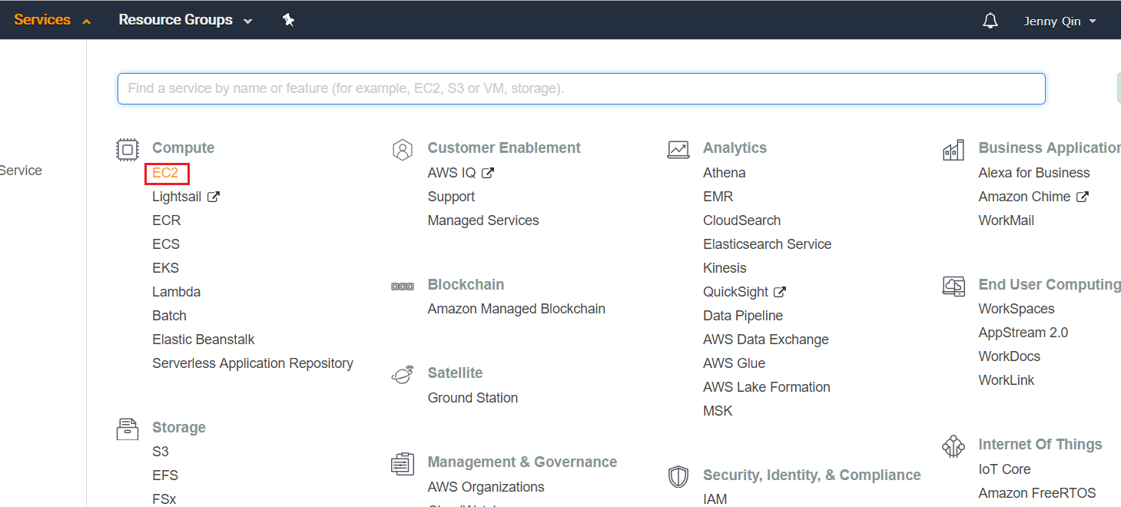

2.Click on the “Load Balancers” on the left navigation.

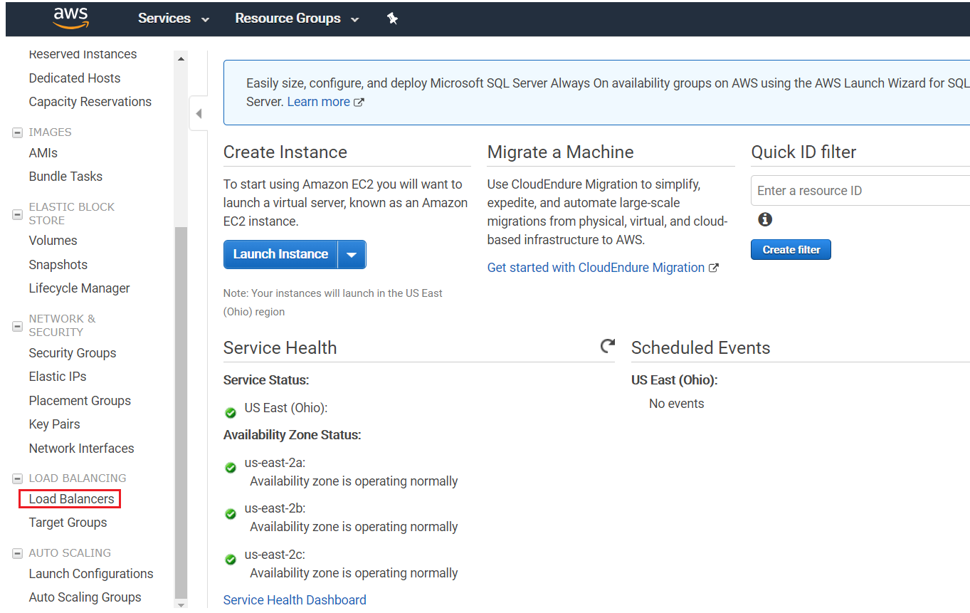

1. Click on the “Create Load Balancer” button.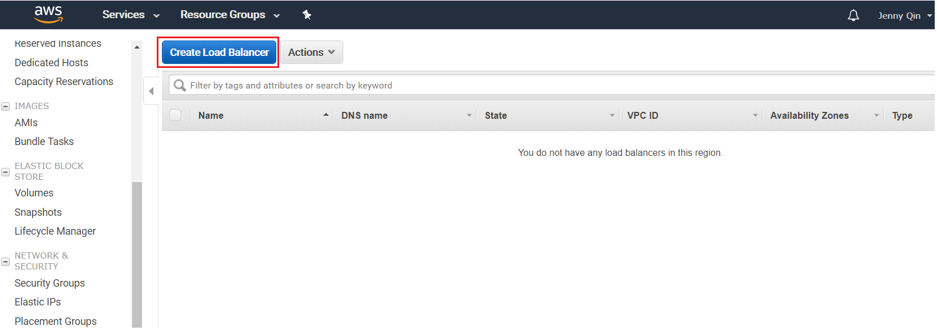
2. Click “Create” in Applicatio Load Balancer.

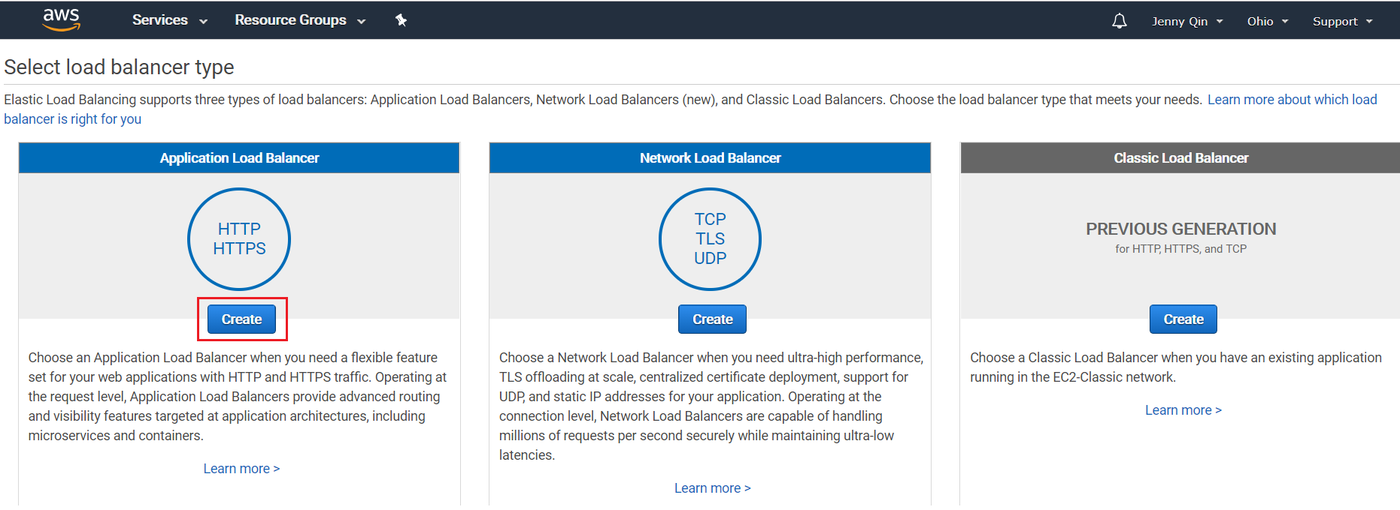

1. Input the load balancer name.Click on “Next: Configure Security Settings”。

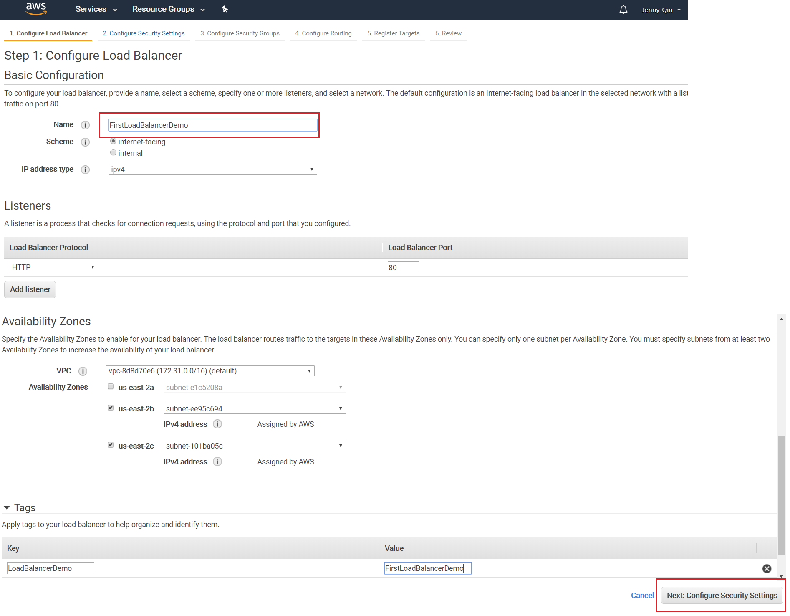

6.保持默认。Click on the “Next: Configure Security Groups”.

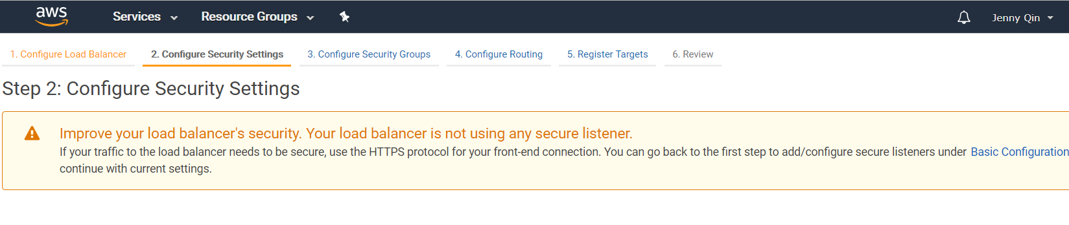

1. 保持默认。Click on the “Next: Configure Routing”.

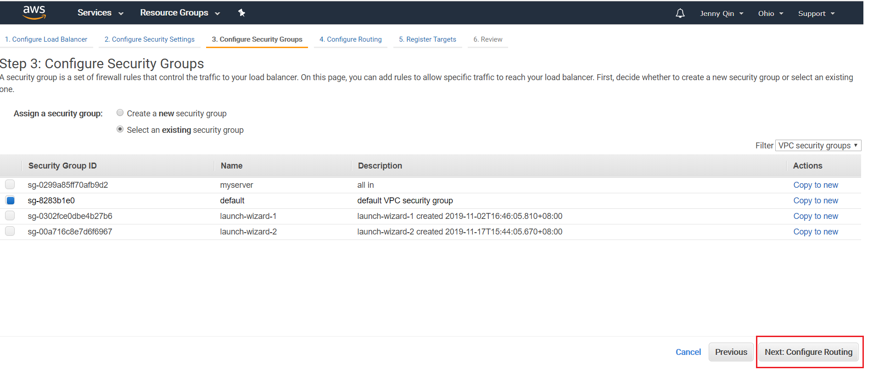

7.Input the Name and click on the “Next Register Targets”.

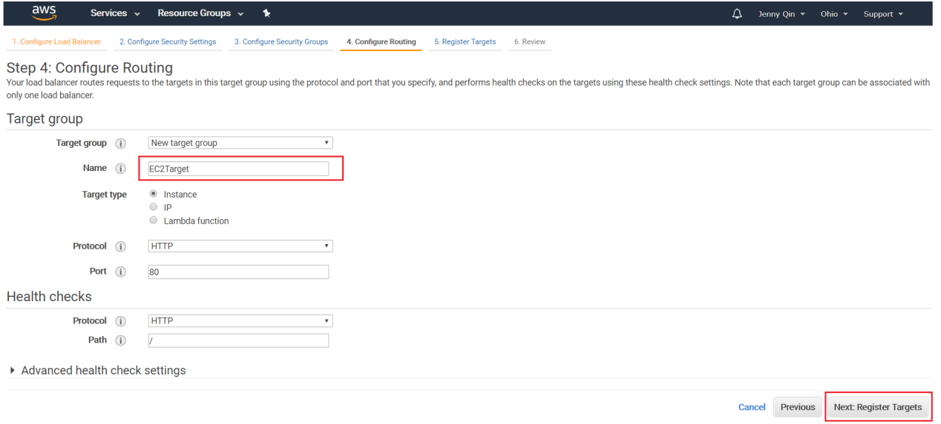

8.Choose your EC2 instances, click “Add to registered” and Click on the “Next:Review”

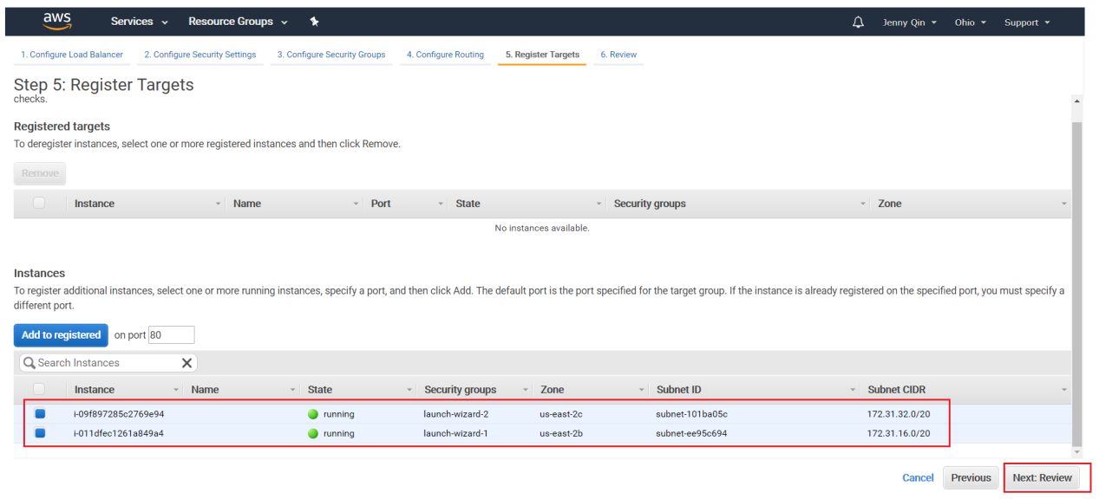

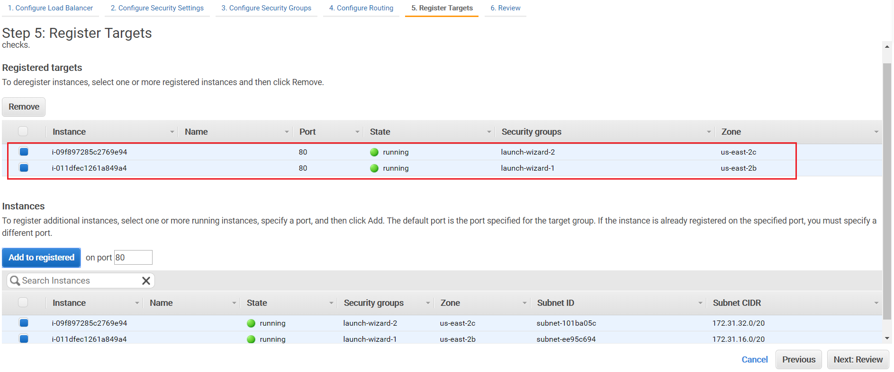

9.After confirmed that your Load balancer configuration are ok, click “create”.

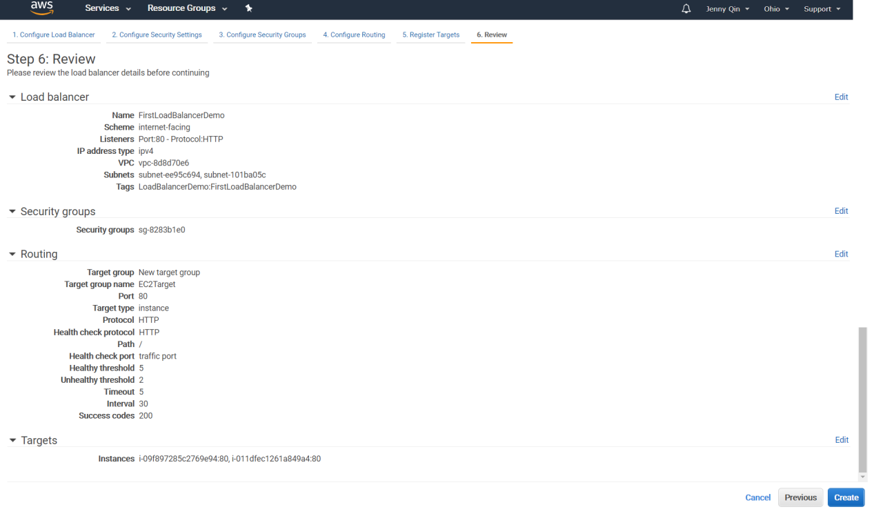

1. Create successfully.

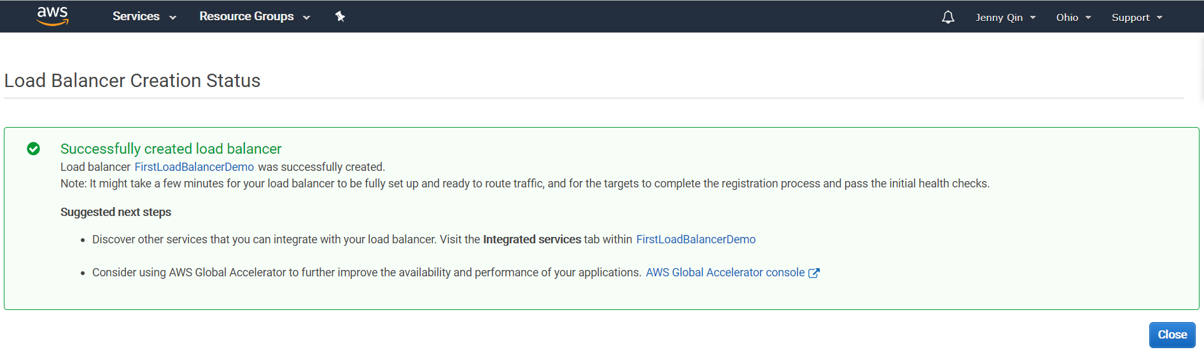

1. Go to “Target Groups” to check your EC2 instances.The request will always be redirect to the healthy instances.Now there is only 1 instance is healthy in the target list.

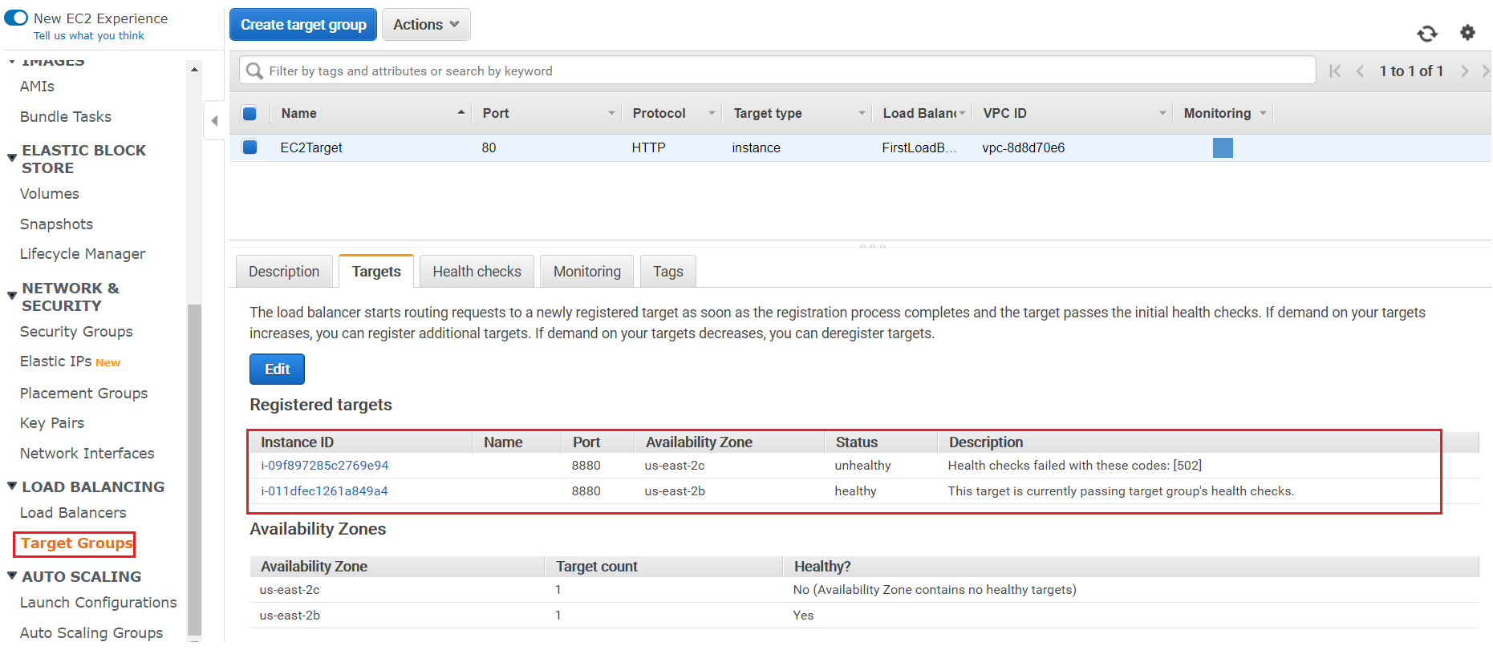

1. Use “DNS name” to test the load Balancer.

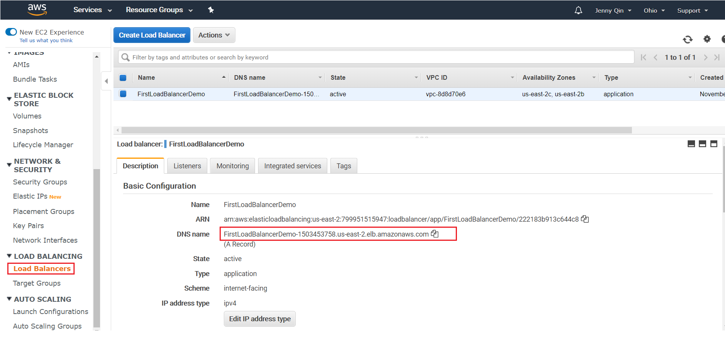

See screen below, you can see that the request has been redirect to EC2 instance from LoadBalancer DNS name.





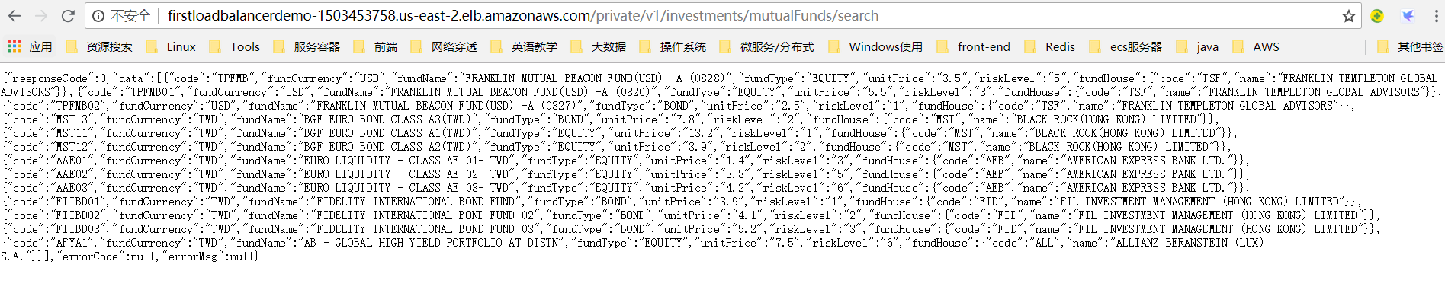

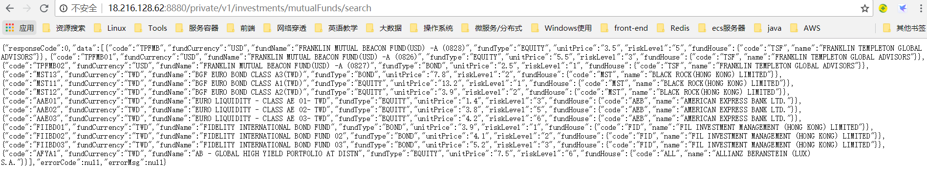

1. After fix the 2nd instance, we can see the request can also redirect to the 2nd instance.

Visit through LoadBalancer.

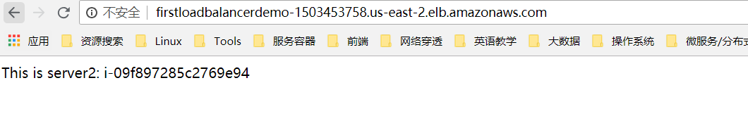



Visit the EC2 instance directly.

